|  |  |  |  |  |  |
| --- | --- | --- | --- | --- | --- |
| Date | 30-Nov-22 | | | Tester Name | Andrew McLaughlin |
| Environment | Penfax - Test | | | Login used |  |
| Operating System | Select OS | Version: | Update: | | |
| Software Used | Select Software | Version: | Update: | | |
| Select Software | Version: | Update: | | |
| Release version | 22.4.1 | | | | |
| Title | Calculates retro amount, if any | | | | |
| Test Type | Regression | | | | |
| Test Scenario | Calculates retro amount, if any | | | | |
|  |  | | | | |
| Expected Results |  | | | | |
| Pass/Fail | Pass | | | JIRA# | N/A |

Describe your steps with screenshots:

Verify the member has a guarantee period in their pension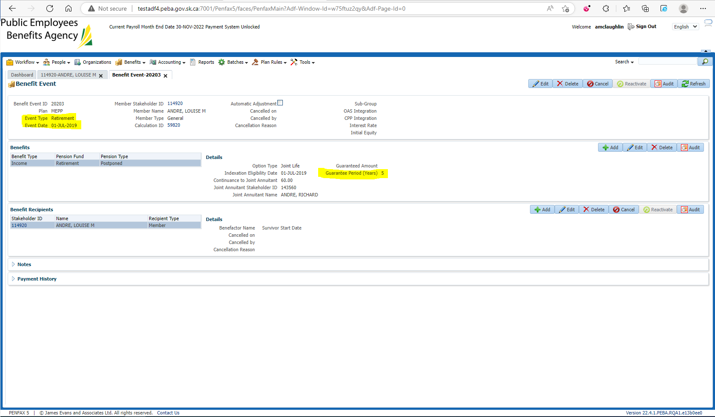

Add their Date of Death under Person Profile > Edit. Pick a date prior to the current month payroll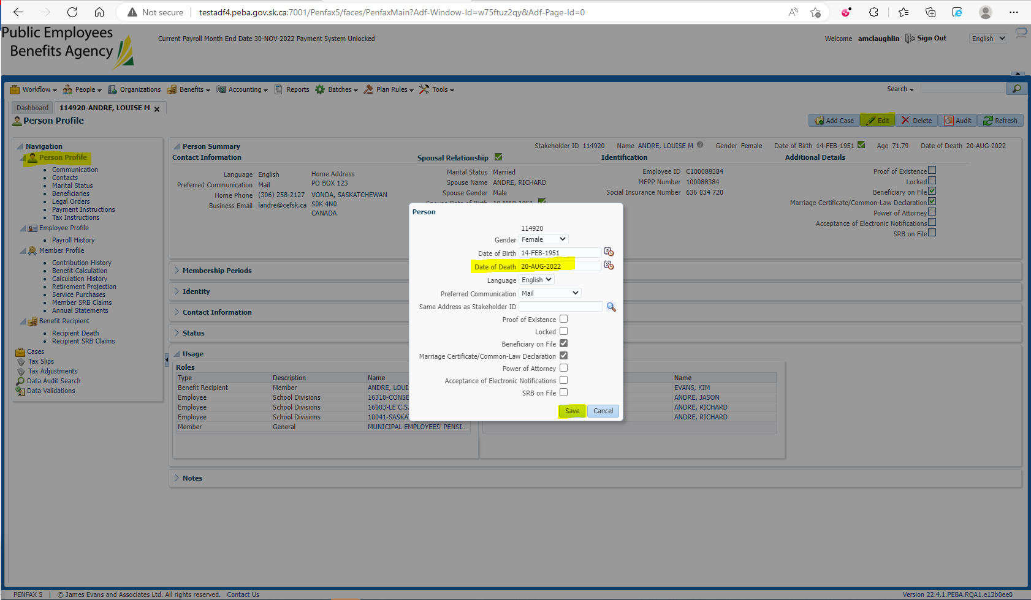

Add the Spouse to the Benefit Recipient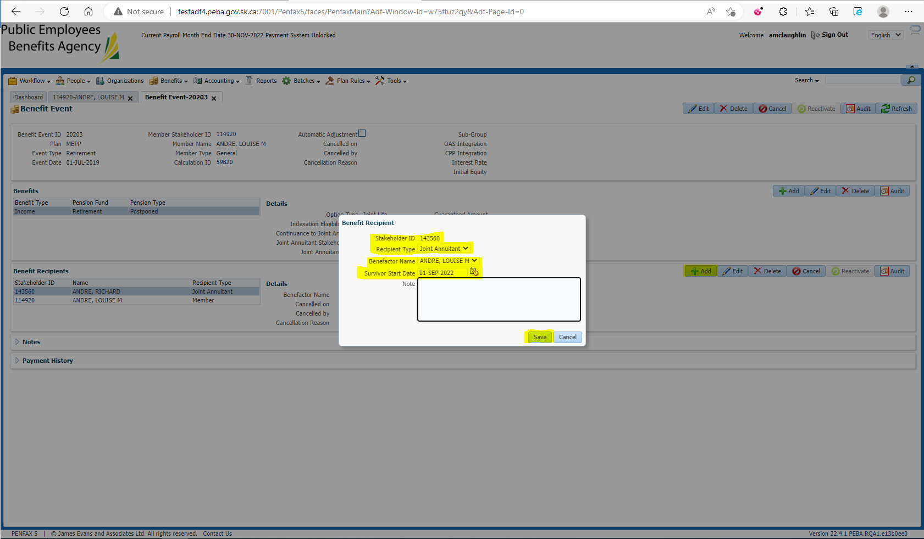

Run the Death Calc, Process x2, Process Recipients x2. Check the GP expiry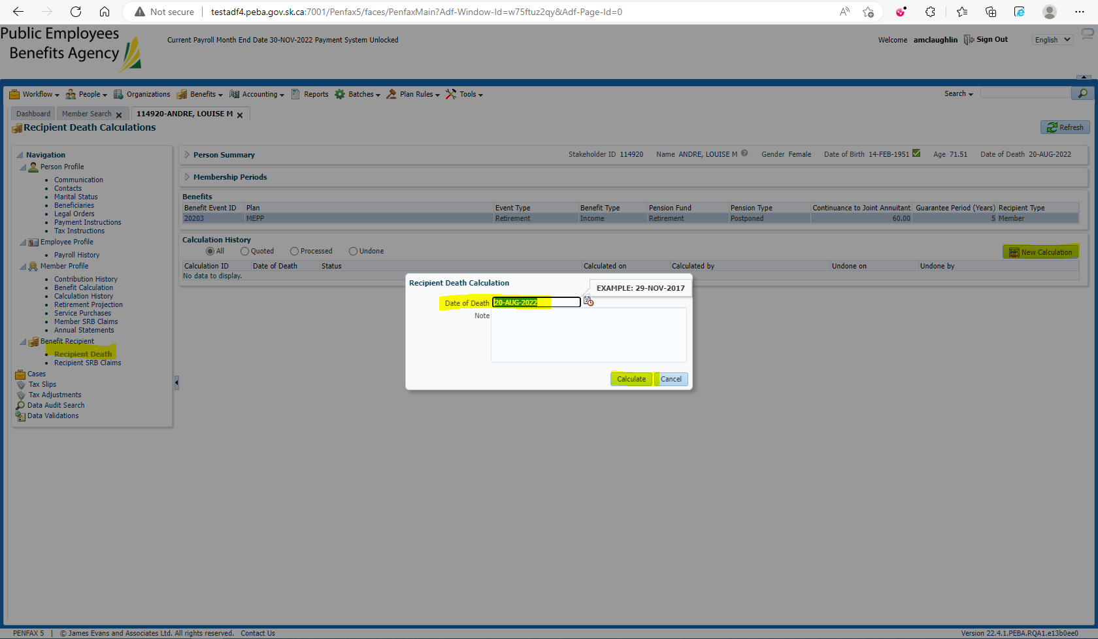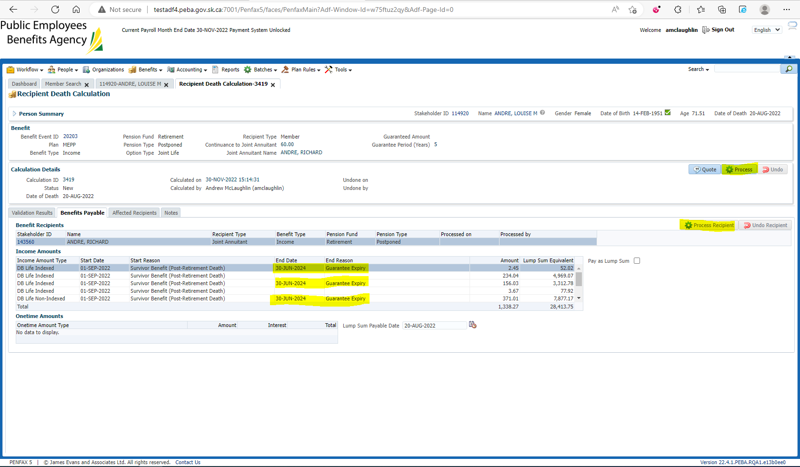

Process survivor retros 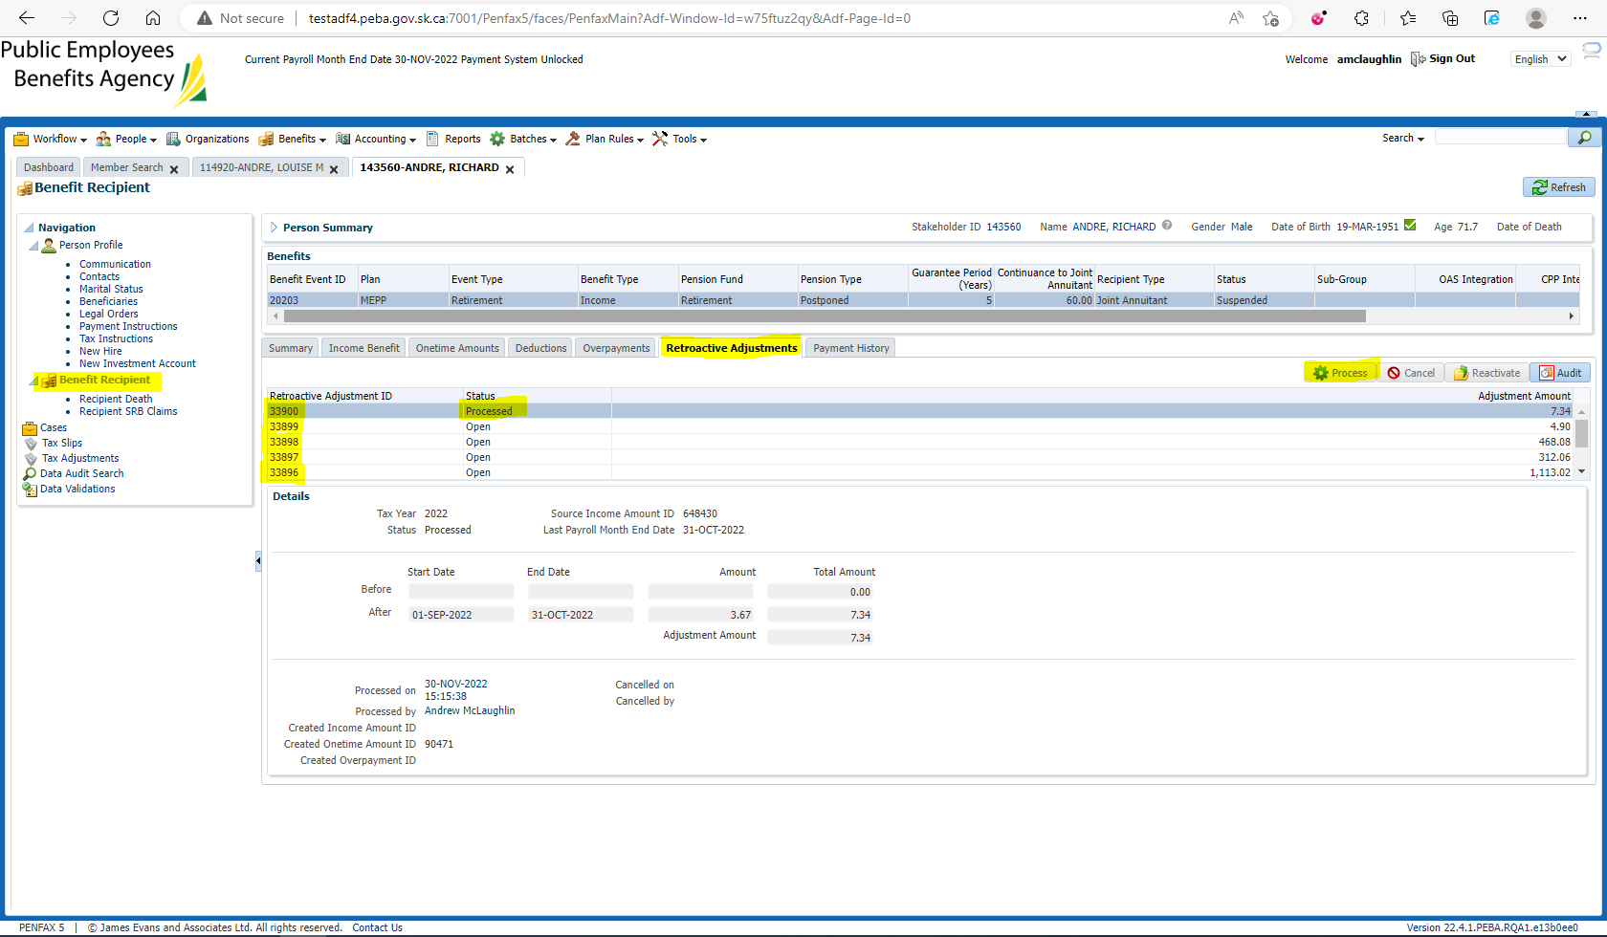

Verify that the amount matches the amount they’ve missed: 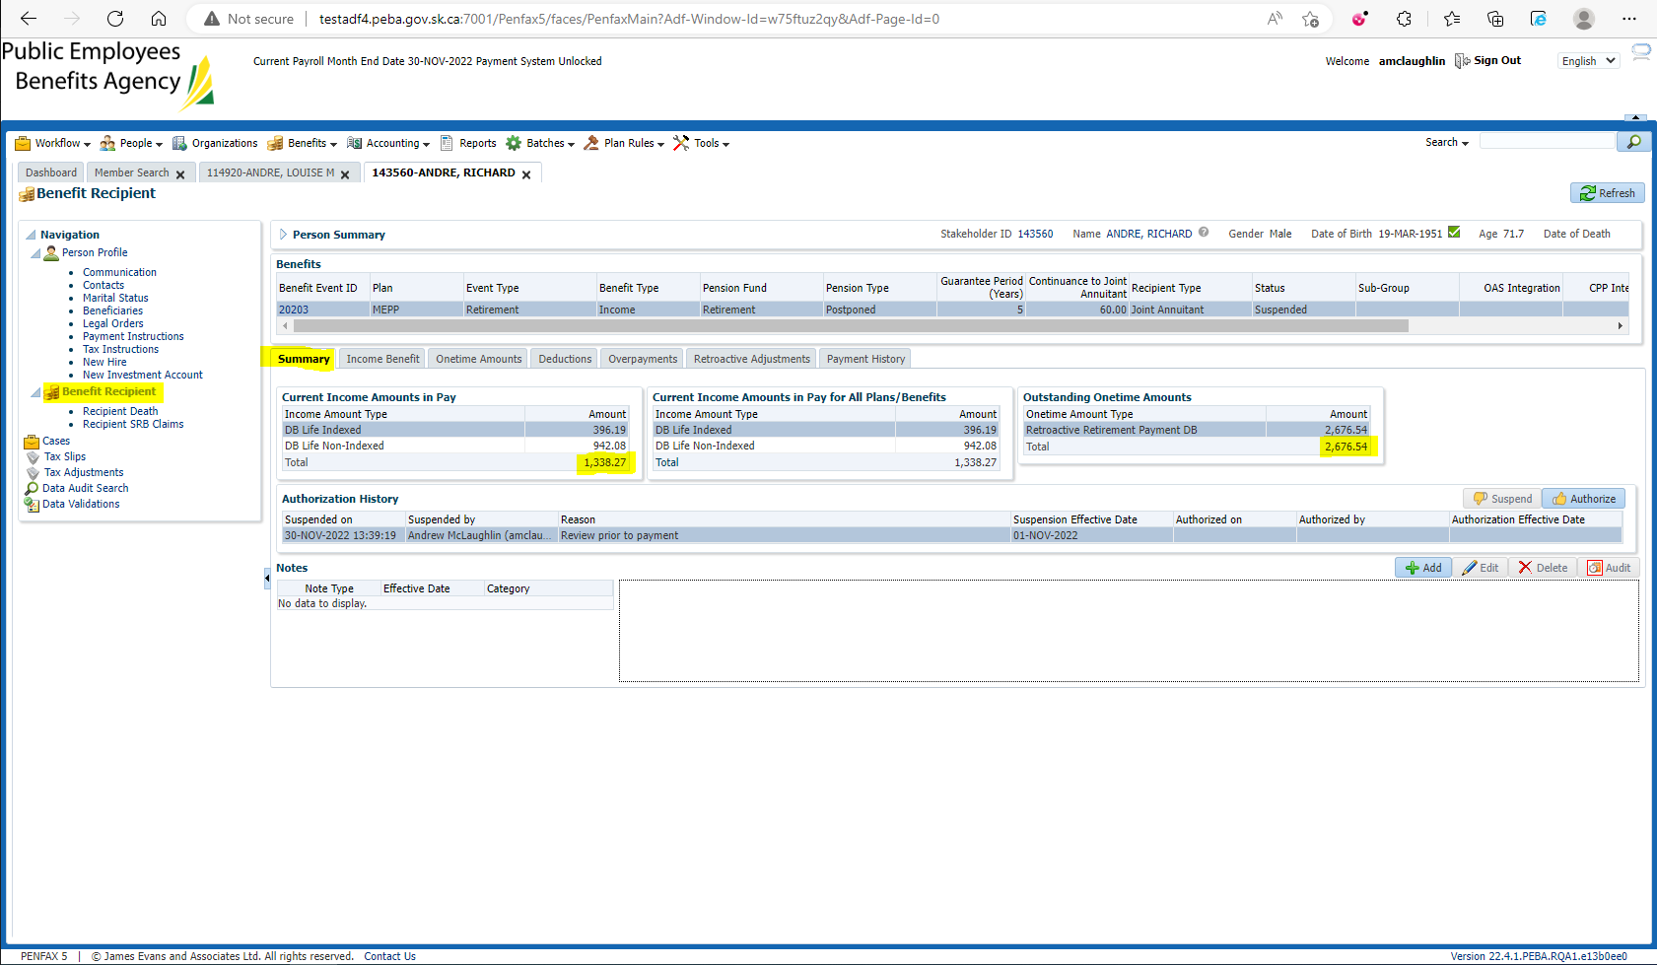

They missed their Sept/Oct payment. 2 Month worth of payments: $1,338.27 * 2 = $2,676.54